Dear diary,

[Gravity - John Mayer]

It’s been a little while since I’ve taken the time to write a diary entry… I have a specific purpose for today’s writing -- and I’ll get to that in a moment. But first, I just want to set the scene:

It’s 1:25 pm on a slow-moving Thursday. I’ve been going HARD for the last few months, and I’ve decided to give myself the next few days off to recover and do basically nothing without feeling guilty. I woke up today at 11:30 am (it felt *amazing*). After waking up, I slowly emerged and made a nice lil’ breakfast for one. I was pretty hungry so I made 2 pieces of sriracha egg toast, and I made some fresh coffee in the french press, and turned it into an oat milk steamed late. I took my food and coffee outside on my treehouse porch and enjoyed a quiet meal by myself with some gentle music playing in the background. [River - Leon Bridges] I was moved from my seat by the territorial squirrel that has made a home near my deck. I looked up at the sky and felt the sun fade away quickly as grey clouds consumed the space above me. College kids were moving into the apartment next to mine and chatting with one another. One loud roar of thunder filled the air, immediately followed by 2 gentle taps of rain drops falling near my feet. Within five minutes, the air had filled with a torrential downpour. I changed my shirt into something a bit thicker, and ran outside into the energizing rain. I twirled and spun in the drops, feeling them consume my skin and my feet. I ran down my stairs and found some grass. I earthed for a minute. Earthing is so *healing* to me. I breathed in beautiful mother nature as she was watered by the sky. I went back to my deck and titled my head towards the sky with closed eyes -- healing through the icy cold soothing drops on my cheeks, forehead, lips, eyelids, and face. I smiled with all of the muscles in my face. I breathed deeply. I breathed the much needed and heavily missed *clean, smoke-free* air deeply into my lungs. I came inside and noticed the gentle music still playing through the speaker in my kitchen. I watched the rain continue to fall on my porch as steam rose up out of the ground, listening to music, feeling emotional. I began to cry. Wether they were happy tears or sad tears, I couldn’t tell you. But I can say that afterwards, I felt relieved. I didn’t need to know why I needed to cry, I just needed to do it.

I’m now sitting in my room in my camping chair underneath the skylight, listening to the rain and watching it hit the window above my head. My clothing is wet and my hair is dripping. My skin is moist and sticking to my laptop. The music is playing on the speaker next to me [Banana Pancakes - Jack Johnson]. I just took a deep breath. Oh I smoked a bowl of weed out of my bong as well. So I’m a little bit high, just a little bit.

I’m happy.

Or rather, I think a more fitting word would be content.

I’m content.

It feels really, really good.

Alright, now to the regularly scheduled programming: the journal prompts that I came here to think through, I’ll write out a list below:

(From Claudia’s journal that she messaged me last night that we wrote together)

* Are you happy with where you are at in life?
* Do you feel independent?
* Are you in control of your life?
* Do you see yourself with Dylan in the Fall?
* What gives you life?

(Form my therapist)

* How do I feel towards relationships?
* What makes me feel “trapped” in a relationship?

**Are you happy with where you are at in life?**

**Yes.**

I am *very* happy with where I am at in my life, in many ways. That being said, of course I can think of ways in which I can *improve* my life, and ways in which I could be *happier* in my life. But in general, I am very proud of myself and my current reality.

I am finally living alone for the first time ever, fully funding myself and my housing and living situation. I am **killing** it in my career in many ways. I am **killing** it in my social life, both professionally and personally. I finally have a community I’ve created here in Boulder that is full of loving, kind, caring people who appreciate me. I am grateful for everything around me. I have multiple people who are falling in love with me or at the very least feel love towards me. I am consistently pushing myself socially and professionally. I am beginning to understand more and more what gives me life and I am putting in the time to make sure that I give that to myself.

I am kind to others. I respect others. I love myself. I respect myself.

I am confident.

I am truly trying my best to live life to the fullest.

**Do you feel independent?**

I do feel very independent. Since living on my own, I think I have felt more independent than ever. Especially today. The ability to wake up at any given time of my choosing, and to do with my day what I’d like to do with my day, without any external factors influencing my immediate decisions… it gives me a much-needed sense of independence that allows me to take the time that I need for myself to recoup and to show up more fully in everything that I do.

I do feel obligated to certain people in my life, such as Kenzie, Jesse, or Dylan - when they ask me to do things I feel bad saying no. But I also feel that I am getting better at recognizing my underlying needs and I am able to say no when I really need to.

Also in general, I just want to list out my community here in Boulder to remember this snapshot in time :)

* Kenzie
* Julie
* Joe (and now Kiki hopefully, I like her! Also hopefully Austin and Lauren too)
* Courtney
* Christian
* Kel (not really, but I think about him a lot at least)
* Spencer and Kyle -- before they moved :’(
* Perran and her boy Alex
* Brianna and Michael when I hang with Julie
* Preston
* Yoga teachers (Sophie, Tunde, Paul Perry)
* Paris
* Mark and Jenn and London
* Dylan
* Samantha
* Janet
* Dianna (hopefully again sometime soon)
* Nasim
* Estelle
* People from the department -- healthy colleague relationships (Katy, Morgan, Kandrea, Shamika, Madelyn, Anthony, Laurie, Ronnie, Junnan, Janghee, Katie Gach, Shiva, Melissa, Noah, Natalie, Brianna, Ellen)
* The guy from salsa dancing who wants me in his band
* Previous hookups: Robert, Ben
* Jack and Austin (from Julie)
* Paragliding folks: Olivia, Liz, Arie, Mauricio, Dylan, Will

I am sure I forgot some folks, but I think this covers it pretty well. I am *so* proud of how far I have come in my short 2 years here, with 1.5 of those being during COVID. And with ~.6 of those spent in places outside of Boulder.

So yes, in conclusion I am feeling very independent, but also with a solid understanding that I need to put in work into my relationships to keep them healthy, and that’s okay.

**Are you in control of your life?**

**Yes, 100%.** There are certain things I am not in control of: e.g., the weather, other people’s emotions, things that I am asked to do by others, things that happen to me, things that happen to others, my addictive personality, etc. But I do think that there is a *lot* in my life that I am in control of -- especially the way I show up in the world, my attitude, my personality, my emotions or at the very least my perspective of those emotions, my actions, and my environment.

The more that I learn about myself the more that I learn what is good for me and also good for others. And the more I am able to control things to maximize the goodness in life.

**Do you see yourself with Dylan in the Fall?**

**Absolutely not.** I don’t see myself with Dylan ever again. I will admit that I had a dream last night where we kissed, and I’m not sure where that came from. I also need to recognize that it is not good for me to villainize our relationship, and I need to remember that there were some really good things in the relationship as well. But, I definitely don’t ever see myself dating him again, and I know that I am better in almost every way without being in that relationship.

**What gives you life?**

I’ll start with a list:

* Health
* Deep breathing
* Self love
* **Confidence**
* Friends
* Family
* Community
* Time to myself
* Time in nature
* Time in rain
* Earthing
* Yoga
* Paragliding
* Rock climbing
* Long boarding
* Listening to good music
* *Dancing* with others
* Dancing alone
* Playing instruments and making music
* Singing
* Being in a clean space
* Spending time with quality people
* Spending time with people who appreciate and respect me
* Giving myself enough time being sober
* Being spontaneous
* Meeting new people who are good people
* Putting myself out there and doing a good job
* Being *present*
* Being well-rested enough to be able to be *present*
* Being single
* Killing it at my career
* Being financially secure
* Giving myself the space to be emotional and to release stagnant emotions
* Living in a clean space
* Freshly brewed coffee
* Fun activities
* Adrenaline
* Trying new things and having a good time
* Laughter
* Love
* Sadness (the appropriate and healthy amount)
* Crying (when it is cathartic)
* Taking care of my plants
* Doing my nightly routine to take care of my body before the next day
* Giving myself compliments
* Receiving compliments
* Hugging (when it’s a *good* hug)
* Spending time in and/or near water
* Spending extended time in nature and/or away from my devices
* Being **present**

I hope to keep growing that list more and more every day that I live.

It feels good to answer all of those questions. I am really grateful that Claudia remembered to send those to me last night. I was supposed to fill them out on May 13th, but they are helpful even now. I actually hope I can come back to those questions (probably with the exception of the Dylan one, that seems to be a closed book) on a regular basis, just to check in.

I was watering my plants, deciding to try to be good to myself last night and listening to sentimental songs in my air pods last night when Claudia texted me. Siri played Claud’s voice message to me while the music stayed playing quietly in the background, hearing Claudia ask those questions while I was watering my plants alone at my new place before bed, it made me want to cry. I am so grateful for her.

Here is how I answered those questions back on April 13th:

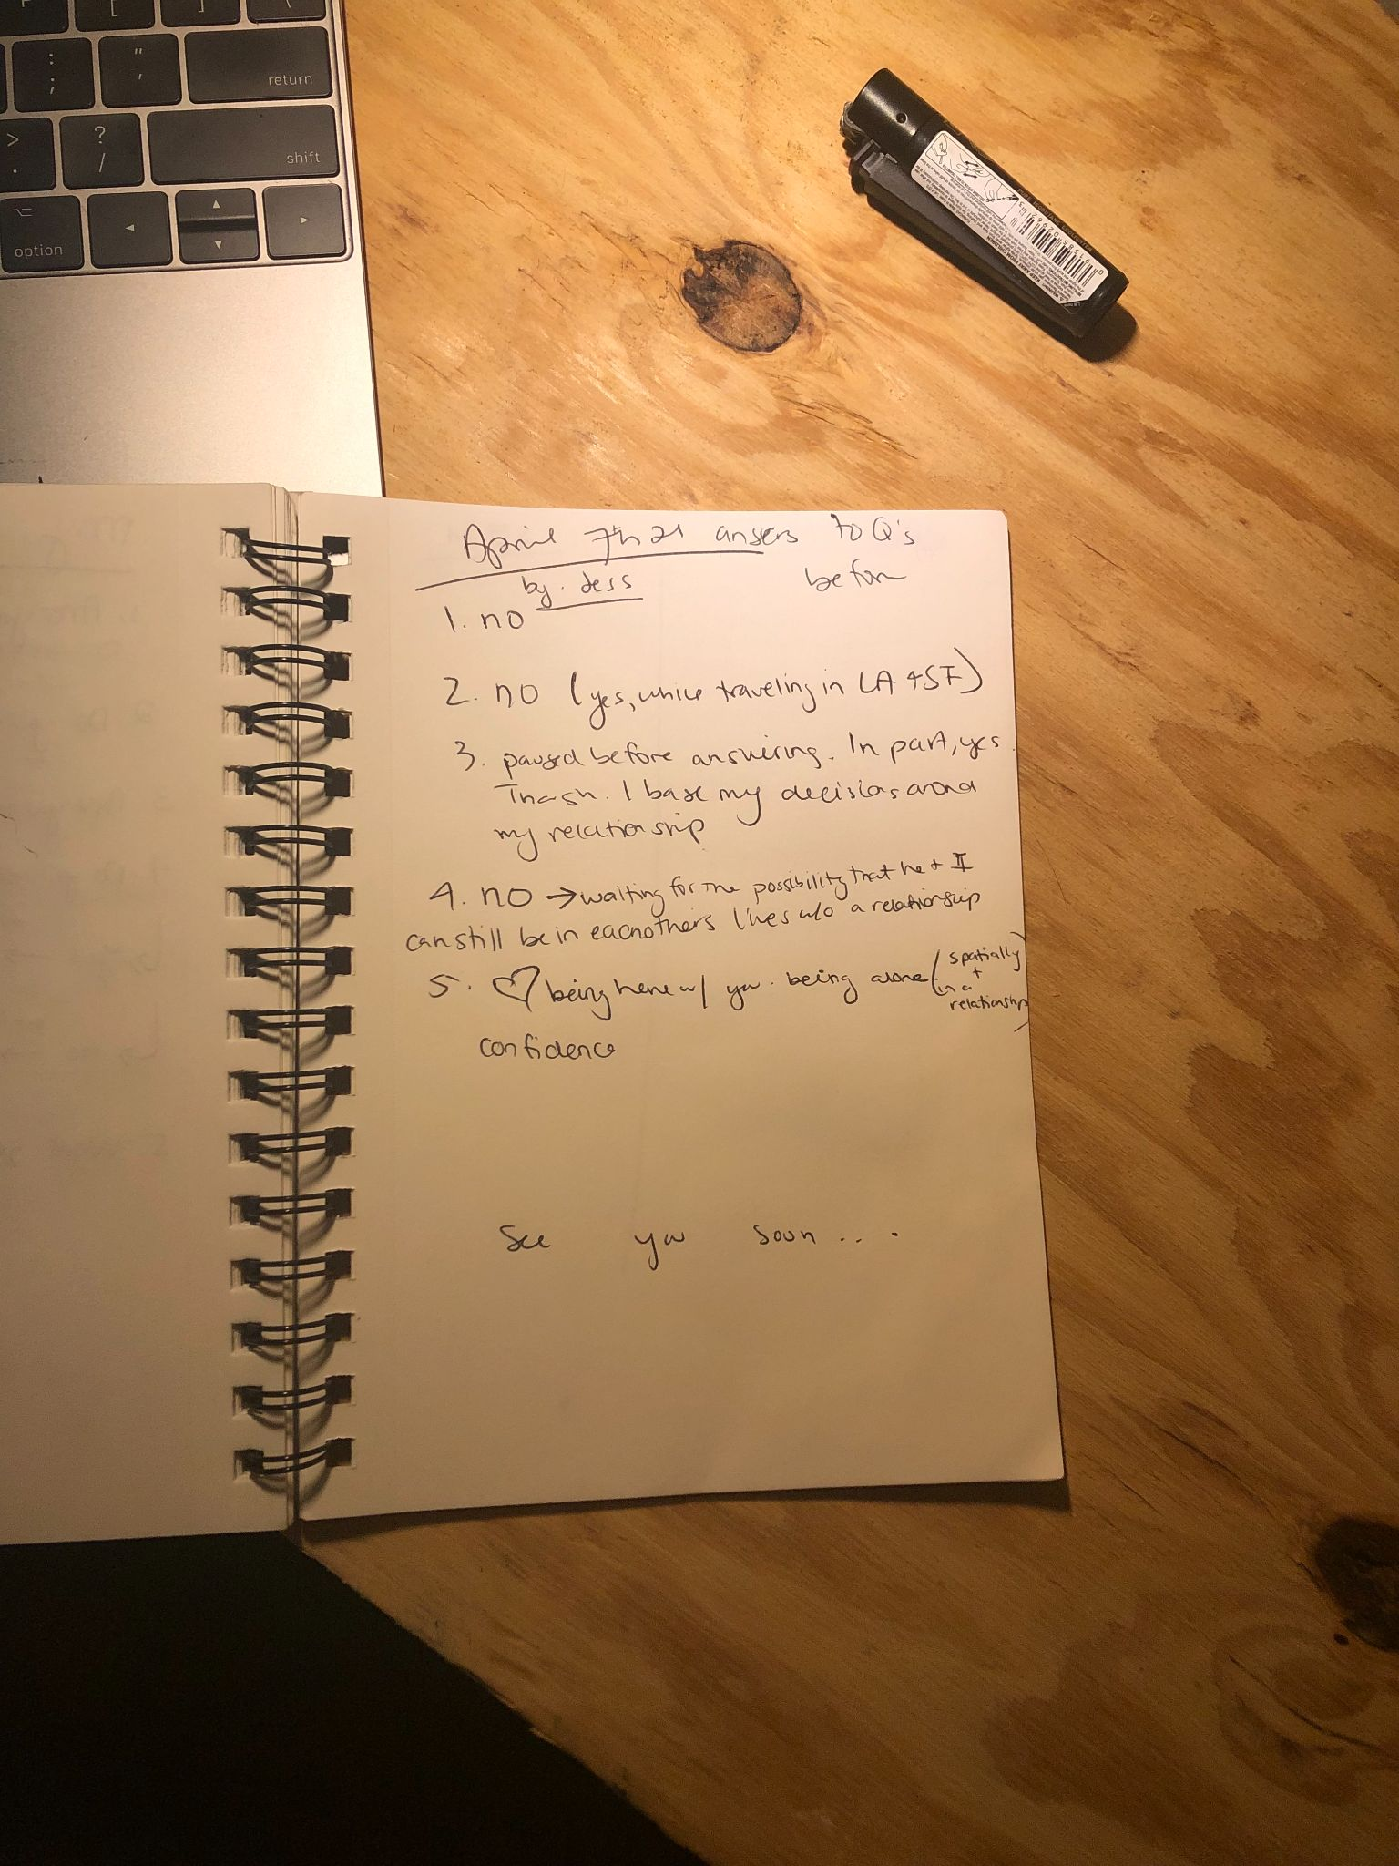

I’d like to think I’ve come a long way in 4 months. <3

Onto the next set of questions, for my therapist (and really questions that I have needed to ponder for a while in my life):

**How do I feel towards relationships?**

**What makes me feel “trapped” in a relationship?**

**I think I am actually going to answer these in inverse order:**

**What makes me feel “trapped” in a relationship?**

There are a lot of things that make me feel trapped in relationships:

* When a guy (or girl) seems to be *too* into me (aka: more into me than I am into them)
* When I don’t see a future with someone, which includes:
  + Me not wanting to introduce them to my friends
  + Me not wanting to introduce them to my family
  + Me feeling depleted at times after seeing them
  + Me not being able to be my best self when I’m with them
  + Me not being physically attracted to someone
  + Me not being intellectually stimulated by someone
  + Me not feeling respected by someone
* When I feel like I can’t be honest with my partner about other people that I am sleeping with or other people that I am interested in or other people who I am emotionally invested in
* When they ask me to be exclusive with them and want us to be exclusive (and aren’t okay with us doing anything otherwise)
* When I feel suffocated, which generally is from me feeling like it will be really emotional and overwhelming to end things. This can be from:
  + Them threatening to hurt themselves if I end things
  + They cry when I try to end things
  + They push back on me ending things and try to find excuses or justify us staying together
  + Them guilting and/or pressuring me to stay with them
* When they are clingy

I feel like this impacts the relationships that I get into as well… it’s interesting because I feel like most of the people I end up seeing are people who make me feel trapped. I wonder if I subconsciously seek out people who I feel will want to latch onto me? Why would I do that to myself though? Is it because I am capable of being closer with people when they have all of their walls down which can only happen when they are in love with me and want me forever? I suppose some of the few men that I have been with who are more open and seeing other people themselves do have a bit of a wall up. And I have a bit of a wall up around them too. I think I place myself at this tension between being close and genuinely intimate with people and being guarded to protect myself from separating or being emotionally hurt by them.

I think I am protecting my heart from being hurt again like I was in high school.

I just reread some of my diary entries from high school around when I found out that Chandler had been trying to cheat on me with Paige.

Wow, that really impacted me. Deeply.

He was my first real love. I lost my virginity to him, I felt so so deeply for him. I wanted to marry him and spend my life with him. I was able to think about being with him for the rest of my life with *excitement* rather than anxiety… he and Nick are the only people that I’ve ever felt that with.

When I found out that Chandler had done that to me, in my diary entry I blamed it on myself (even though I knew that I shouldn’t). I blamed it on myself because at that point, four guys who I had been into had lied to me -- Kip had lied to me about being over his girlfriend Maddie (who he ended up MARRYING after he and I broke up, I totally forgot about that!!). Douglas had lied to me about wanting to be with me and to go to prom with me, and ended up choosing many other women over me. Nason just stopped talking to me and wanting to hang out - and I think it was because he started dating another girl (if I remember correctly). So I suppose saying these boys *lied* isn’t necessarily true, but they all did end up choosing other girls over me…

Wow, that really fucked me up didn’t it? Now I literally only want to be in a position where I allow men to be with other girls and where I can be with other people so that I am in control. I don’t ever want to be blind sided again by a partner, so I want to give them the ability to do whatever they want in order to protect my heart…

I literally wrote after Chandler and I broke up that “I just want Chandler to not love me anymore. It hurts so much to say that, but honestly it will give both of us time to become our own person again. I’m excited to see what I can become this time around. There’s this really great single, caring girl named Jessie Smith that I haven’t seen in quite a while, and I’m excited to get her back. So, here is to what was probably one of the most emotional, fulfilling, and life altering years of my life.”

In that passage, I realized something -- part of what made me feel so trapped in the relationship with Chandler (besides worrying that he was going to kill himself if I broke up with him) was that I felt like I had assimilated into him. I felt like I had become him, had started hanging out more with his friends than mine, and I felt like I was doing the things that *he* liked rather than what I liked. My life revolved around that relationship, I think that has been a recurring theme in my relationships too… it’s really hard for me to incorporate a new person into my existing life, so instead I just assimilate into theirs. And then I become the person that I either know or assume they want me to be. With Jesse right now that means I am a total stoner when I’m with him, and I do the activities he wants to do without thinking of what I want and what is good for me. With Dylan I did that same, I became exactly what he wanted. I just assimilate and alter and mold myself to be the perfect person for my partner, instead of just staying who I am and seeing if they would like to stay or leave… So I guess to add to my previous list, of things that make me feel trapped in a relationship, I would include:

* When I become the person that *they* want me to be rather than being my own person

Damn. That’s one of the hard parts isn’t it? I’m so good at being what others want me to be (at my own expense as well) that I could literally date almost anyone. So when people show affection and love towards me and I enjoy spending time with them enough, even if it isn’t good for me I will stay in it because I love being the person they want me to be so badly. I love seeing them happy. But then I feel very trapped, and once that feeling emerges, it doesn’t go away. It stays until it eventually destroys the relationship and I have to find way out.

**How do I feel towards relationships?**

Honestly, I think that this might take too long for me to holistically cover today. It’s a BIG topic that needs some very thoughtful reflection. I will spend a few minutes on this topic though and see what comes into my head.

In general, relationships scare the living shit out of me. They make me feel anxious, they make me feel out of control, they make me feel less independent, they make me feel less like myself, and they make me feel trapped and suffocated and fearful of the future.

That being said, obviously there are pros to relationships too -- I *love* feeling love towards others, I love feeling loved by others, I love feeling appreciated by others, I love physical touch, I love compliments, I love going out of my comfort zone, I love having someone I can go to when I’m feeling lonely, I love experiencing things with people…

But I haven’t felt a genuine want or desire to spend my life with anyone ever since the first half of my relationship with Chandler and the first half of my relationship with Nick…

I genuinely don’t know if relationships can be good for me. So far they have all ended up being bad for me in various ways, to the point where after the breakup happens, I feel a weight lifted off of my shoulders and I feel like I return to my true self again.

There’s a lot more to unpack here… so I’ll save that for when I have had a bit more time to reflect.

Actually, I think I’m going to call it good for today’s entry. 10 pages seems to be a good start to reflecting on my current state in life (lol).

In summary, I am really happy with where I am. Sure, I smoke more weed than I would ideally like to, and I don’t always take perfect care of myself with self care or food or self love, but I’m working on it.

I’m envisioning my best life, and I’m taking active steps to get there every day.

I’m doing the best I can, and for that, I’m immensely proud of myself.

It’s 3:45 now. The rain has died down and the sun has started to emerge.

I think I’ll go try to finish unpacking my new place now.

More soon.

<3

Love,

Jess

Age: 24